Analysis and Summary

DAD 220 Intro to Struct Database Environment

Sergio Mateos

Southern New Hampshire University

# DAD 220 Analysis and Summary Template

Replace the bracketed text in this template with your responses and any supporting screenshots. Then submit it to the Module Five Activity for grading and feedback. Rename this document by adding your last name to the file name before you submit.

1. **Analyze the data** you’ve been provided with to **identify themes**:
   1. Which parts are being replaced most?
      1. 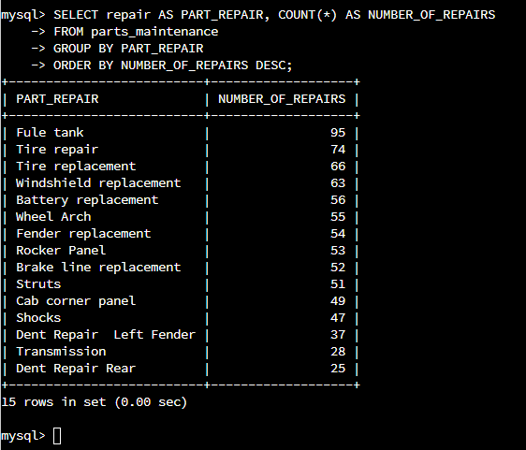The Fuel Tank is the most replaced part with a number of 95 significant higher than the rest of the table
   2. Is there a region of the country that experiences more part failures and replacements than others?
      1. Identify region:
         1. 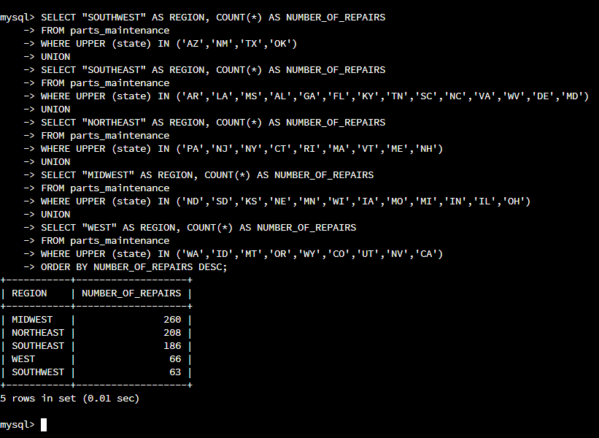The Midwest is the region with the highest amount of repair with an amount of 260.
      2. How might the fleet maintenance team use the information to update its maintenance schedule?
         1. The information above will help the maintenance fleet team to focus on the states with the most number of repair. The logistic department can focus in those states with the most demands of parts.
   3. Which parts are being replaced most due to corrosion or rust?
      1. Text

         Description automatically generatedWheel Arch is the most corrosive or rust part being replaced. Wheel Arch has a number of 55, but Fender replacement is almost as much as Wheel Arch so if we need to focus in part I will prioritize both of them.
   4. Which parts are being replaced most because of mechanical failure or accident, like a flat tire or rock through the windshield?
      1. Text

         Description automatically generatedThe part is being replaced the most are Tires. The Tires has an amount of 74 and basically.
2. **Write a brief summary of your analysis** thattakes the information from Step 1 and presents it in a way that nontechnical stakeholders can understand.
   1. First to represent the data needed I created a table that will contain the information needed for each question, for example, I created a table that will contain information for what region has the most repairs, the table compared all the stated in the region and will display the necessary data for the problem. The data help to find specific values needed.
3. **Outline the approach** that you took to conduct the analysis.
   1. What queries did you use to identify trends or themes in the data?
      1. The queries used to identify trends were SELECT to select the data needed, COUNT to determine count row return, FROM to list the tables and any joins required, GROUP to specify a group row-based, ORDER used to sort the result set in ascending or descending order.
   2. What are the benefits of using these queries to retrieve the information in a way that allows you to provide valuable information to your stakeholders?
      1. The benefits of using these queries will retrieve information by being able to analyze incident and the loculations.
4. **Explain how the functions in the analysis tool** allowed you to organize the data and retrieve records quickly.
   1. The functions COUNT, SELECT, WHERE, and ORDER allow the integration of information and pulled together in an organized manner. This way the data can be analyzed easier to determine a verdict.